Module 8 Java Concurrency Analysis

Michael Maye
Colorado State University Global
CSC450: Programming III
Mr. Bari
July 9th , 2023

Portfolio Milestone I
This system is an example of multi-threading in Java. It uses three classes to create two unique threads that concurrently count from zero to twenty, then back down from twenty to zero. Using the CountingThread class, they system implements the Runnable interface to create two threads: one for the countUp() function and one for countDown(). It utilizes synchronization constructs such as locks (ReentrantLock) and conditions (Condition) to ensure the output is in the correct order. Several potential concerns exist with a system of that uses multi-threading, including deadlocks and race conditions, performance bottlenecks, string manipulation vulnerabilities, and improper exception handling..
Analysis and Observations
Deadlocks, where a threads hold a resource the other(s) need and are essentially frozen as they cannot move on until the others release the required resource, and race conditions, where multiple threads perform actions or access a shared resource and modify it without proper synchronization, are always a concern when working with threads. Race conditions and deadlocks, if left unhandled, have the potential to cause unpredictable and unwanted results during runtime. The system provided in this submission overcomes these concerns by utilizing locks (Lock) and conditions (Condition) to synchronize access to the shared Counter object, ensuring that only one thread can access it at a time, as well as the use of conditions and signaling between threads also prevents potential deadlocks by ensuring proper notification and synchronization.
String manipulation vulnerabilities are a potential concern when shared strings resources are utilized by multiple threads simultaneously. When multiple threads access a globally declared string, extreme caution must be taken to avoid conflicts and unsynchronized operations to prevent unintended changes to the string's value during runtime. In addition to globally declared strings, the use of System.out.println() and other similar output operations with multiple threads can output incorrect or erroneous data if left unsynchronized. The submitted code uses logMessage strings that are constructed within the scope of their respective countUp() and countDown() functions, which is only accessed by one thread, ensuring that each thread has its own separate string which avoids conflicts or race conditions.
Implementing multiple threads also brings concerns with performance and bottlenecking. If threads are in conflict when trying to access a shared resource, or the system implements frequent locking/unlocking of required operations, it can lead to performance bottlenecks and increased computational overhead within the system. In contrast, if the required work is unevenly distributed between implemented treads, it can lead to one thread completing its operations long before the others and causes CPU underutilization. The system in this analysis is designed to keep tasks performed by the threads computationally light, which ensures the impact on performance is minimal. Given the simplicity of the program, no significant performance issues are observed.
Exception handling is crucial in multi-threaded programs. If a thread encounters an error or exception and it is not properly handled, the thread may terminate unexpectedly, leading to potential issues in the program's execution. Exception handling becomes more challenging in multi-threaded environments due to the increased complexity and potential concurrency issues. In the code, exceptions are caught within the threads using a try-catch block, and they are stored in an array (threadExceptions) of Throwable objects. Once both threads complete their tasks, the main thread checks the threadExceptions array for any exceptions thrown during runtime. If any exceptions are found, they are rethrown to be handled appropriately.

Screen Shot
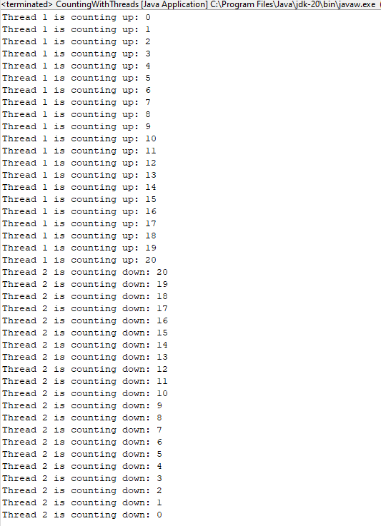
References
Goffi, A., Gorla, A., Mattavelli, A., & Pezzè, M. (2023). Intrinsic redundancy for reliability and beyond
Java platform, Standard Edition Java API Reference. java.util.concurrent (Java SE 14 & JDK 14). (2020, August 27). https://docs.oracle.com/en/java/javase/14/docs/api/java.base/java/util/concurrent/package-summary.html
Oracle Inc. (2023, May). Secure Coding Guidelines for Java SE. Secure coding guidelines for java SE. https://www.oracle.com/java/technologies/javase/seccodeguide.html
Redko, A. (2018, January 4). Concurrency best practices - java code geeks - 2023. Java Code Geeks. https://www.javacodegeeks.com/2015/09/concurrency-best-practices.html
SEI. (2010, May). Java concurrency guidelines. https://resources.sei.cmu.edu/asset_files/TechnicalReport/2010_005_001_15239.pdf

